AKS PROD Architecture:

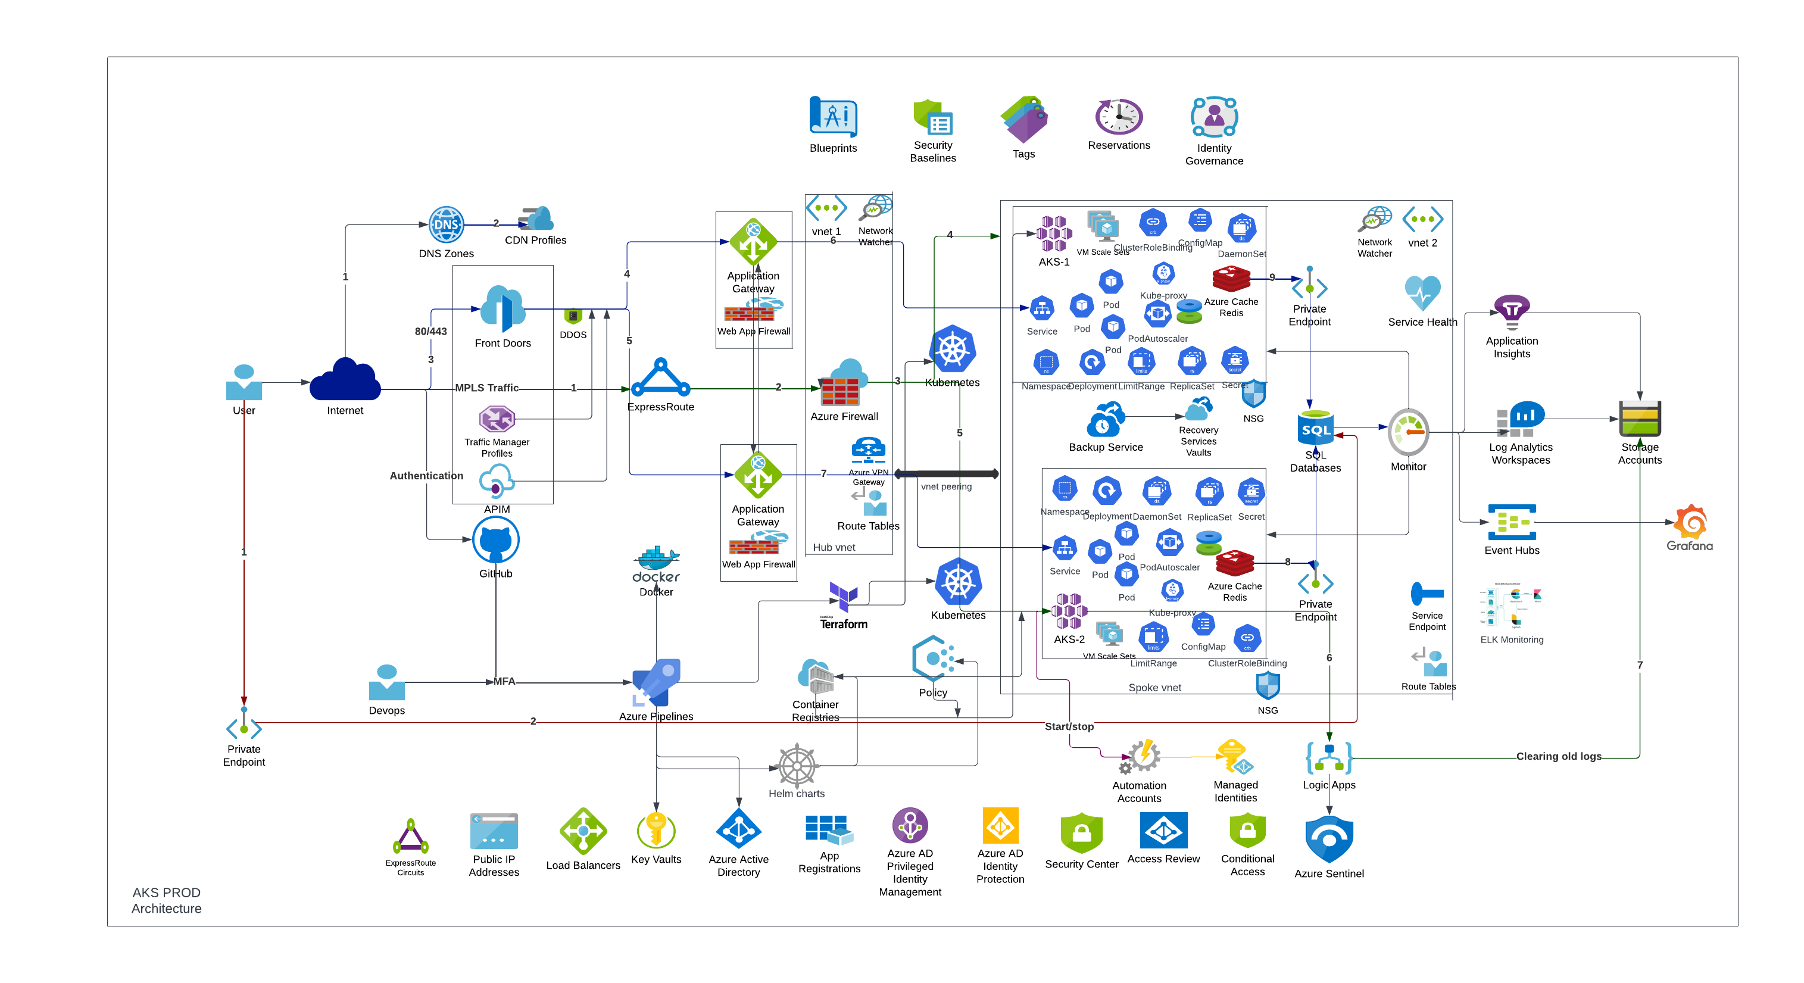

**Data Flows:**

* Resource provisioning using Terraform via Azure CICD pipelines.
* Validating the Resources and checking the basic configurations.
* Application Deployment Using Helm Package through YAML CICD Pipelines.
* Validating the Deployment and Application Accessibility.
* Azure AD Integration for Authentication between Azure CICD and Azure.
* Managed disk as a Persistent Volume Storage backed by Azure Backup-service.
* Data cached by Redis whenever Application data is retrieved from SQL Database.
* Log Analytics, Application Insights, Event Hubs and Grafana are proposed as a Monitoring Solution with Storage Account Backend.

**Current Architectural Achievements:**

1. Cluster and Horizontal pod Autoscaling enabled to support variable amount of traffic.
2. Azure backup service will be enabled for Regular Incremental backups of the data and will be recovered anytime.
3. Regional level failure is supported in this Architecture by Active-Active Load Balancing.
4. The service can be migrated over to any regions with the ASR strategy.
5. Supports multiple developers to work in the project and test multiple features with CICD Branching Strategy Approach.
6. Dev, test and Prod can be deployed with the CICD Automated Approach (whenever required).
7. Monitoring is enabled at Resource level, Cluster level and Application level.